Exercise 9 - Filesystem Access

1. **Review questions**

Notice that the questions below refer to ‘ordinary’ users, and that restrictions discussed do not apply to user ***root*** (or any other user with **UID=0**).

1. What permissions are required to copy a file?

Read, write and execute

1. If a directory has the ‘sticky bit’ set, can you remove a file located in it (assume you have the write permission on that directory)?

If there is a sticky bit, you can only remove the file if you own the file

1. What permissions will be assigned to new files and directories if the value of umask is 002?

Others will have write permissions

1. What is the purpose of the SUID and SGID permission bits?

To give users access to files which would otherwise be restricted

1. What command would assign new group ownership to **project** directory and its entire content?

sudo chgrp (assign ownership) project

1. **In this lab, we will use file-permission modification commands.**
2. Change to your home directory, take a copy of the ***/etc/group*** file and check at its permission flags.





1. Remove from the **group** file the read permission (for the file owner only) and then run a command that would count lines in the **group** file.

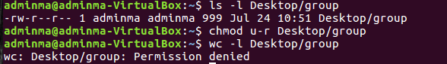

1. Remove the group file from your home directory. Are you surprised that it worked? Which permissions were consulted for the purpose of this operation?



execute

1. Now try:

$ **rm –f /etc/group**

Why can’t you delete the file?

No execute permissions

1. **This lab investigates the directory access permissions, the *x* bit.**
2. You should still have a directory called ***project2*** (created in an earlier lab).



If, by any chance, this directory no longer exists, create it (in your home directory).

1. Put a couple of files in your **project2** directory; you can use **cp**, **touch**, **>** , or any method you prefer, even **vi** ;-)



1. Make sure you are in your home directory, and then take away (from yourself) the ***x*** bit from the **project2** directory.



1. What are the implications of what have you just done? Use **ls** and **ls -l** on the **project2** directory and interpret the results.

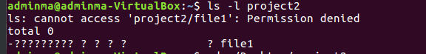

1. Can you successfully change into the **project2** directory ?



1. Now re-assign the search permission to the **project2** directory, and test that you can again do the long listing of **project2** (change into it, etc).

